**Lab Exercise 5**

**AIM: Exceptions and Threads**

**1. Exceptions**

class Exc0{

public static void main(String args[]){

try{

int d, a;

d=0;

a=18/0;

System.out.println("this method will not be printed");

}

catch (ArithmeticException e){

System.out.println("Division by zero");

}

}

}

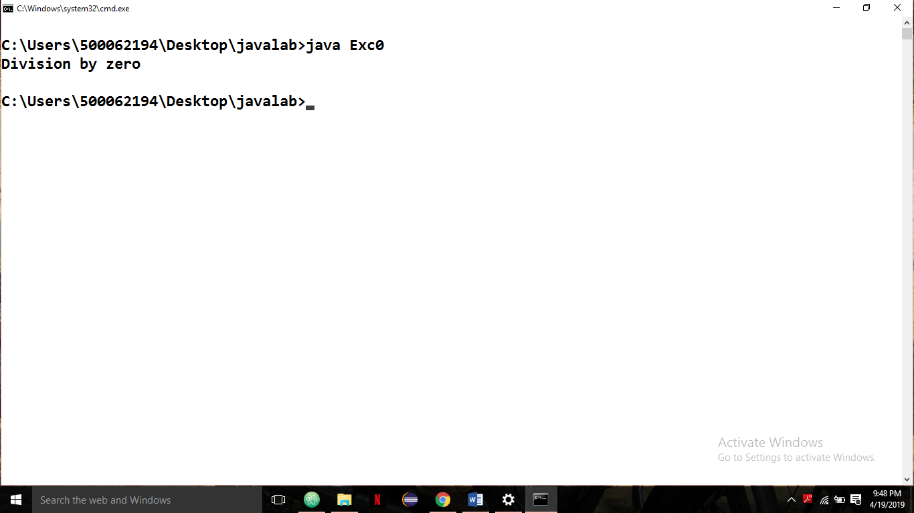

**2. Threads**

class Myclass extends Thread{

public void run(){

for(int i=0; i<10;i++){

System.out.println(Thread.currentThread().getId()+" value "+i);

try{

Thread.sleep(2000);}

catch (InterruptedException e){

e.printStackTrace(); } } }}

public class CurrentThreadDemo{

public static void main(String args[]){

Myclass myClass1=new Myclass();

myClass1.start();

Myclass myClass2=new Myclass();

myClass2.start(); }}

